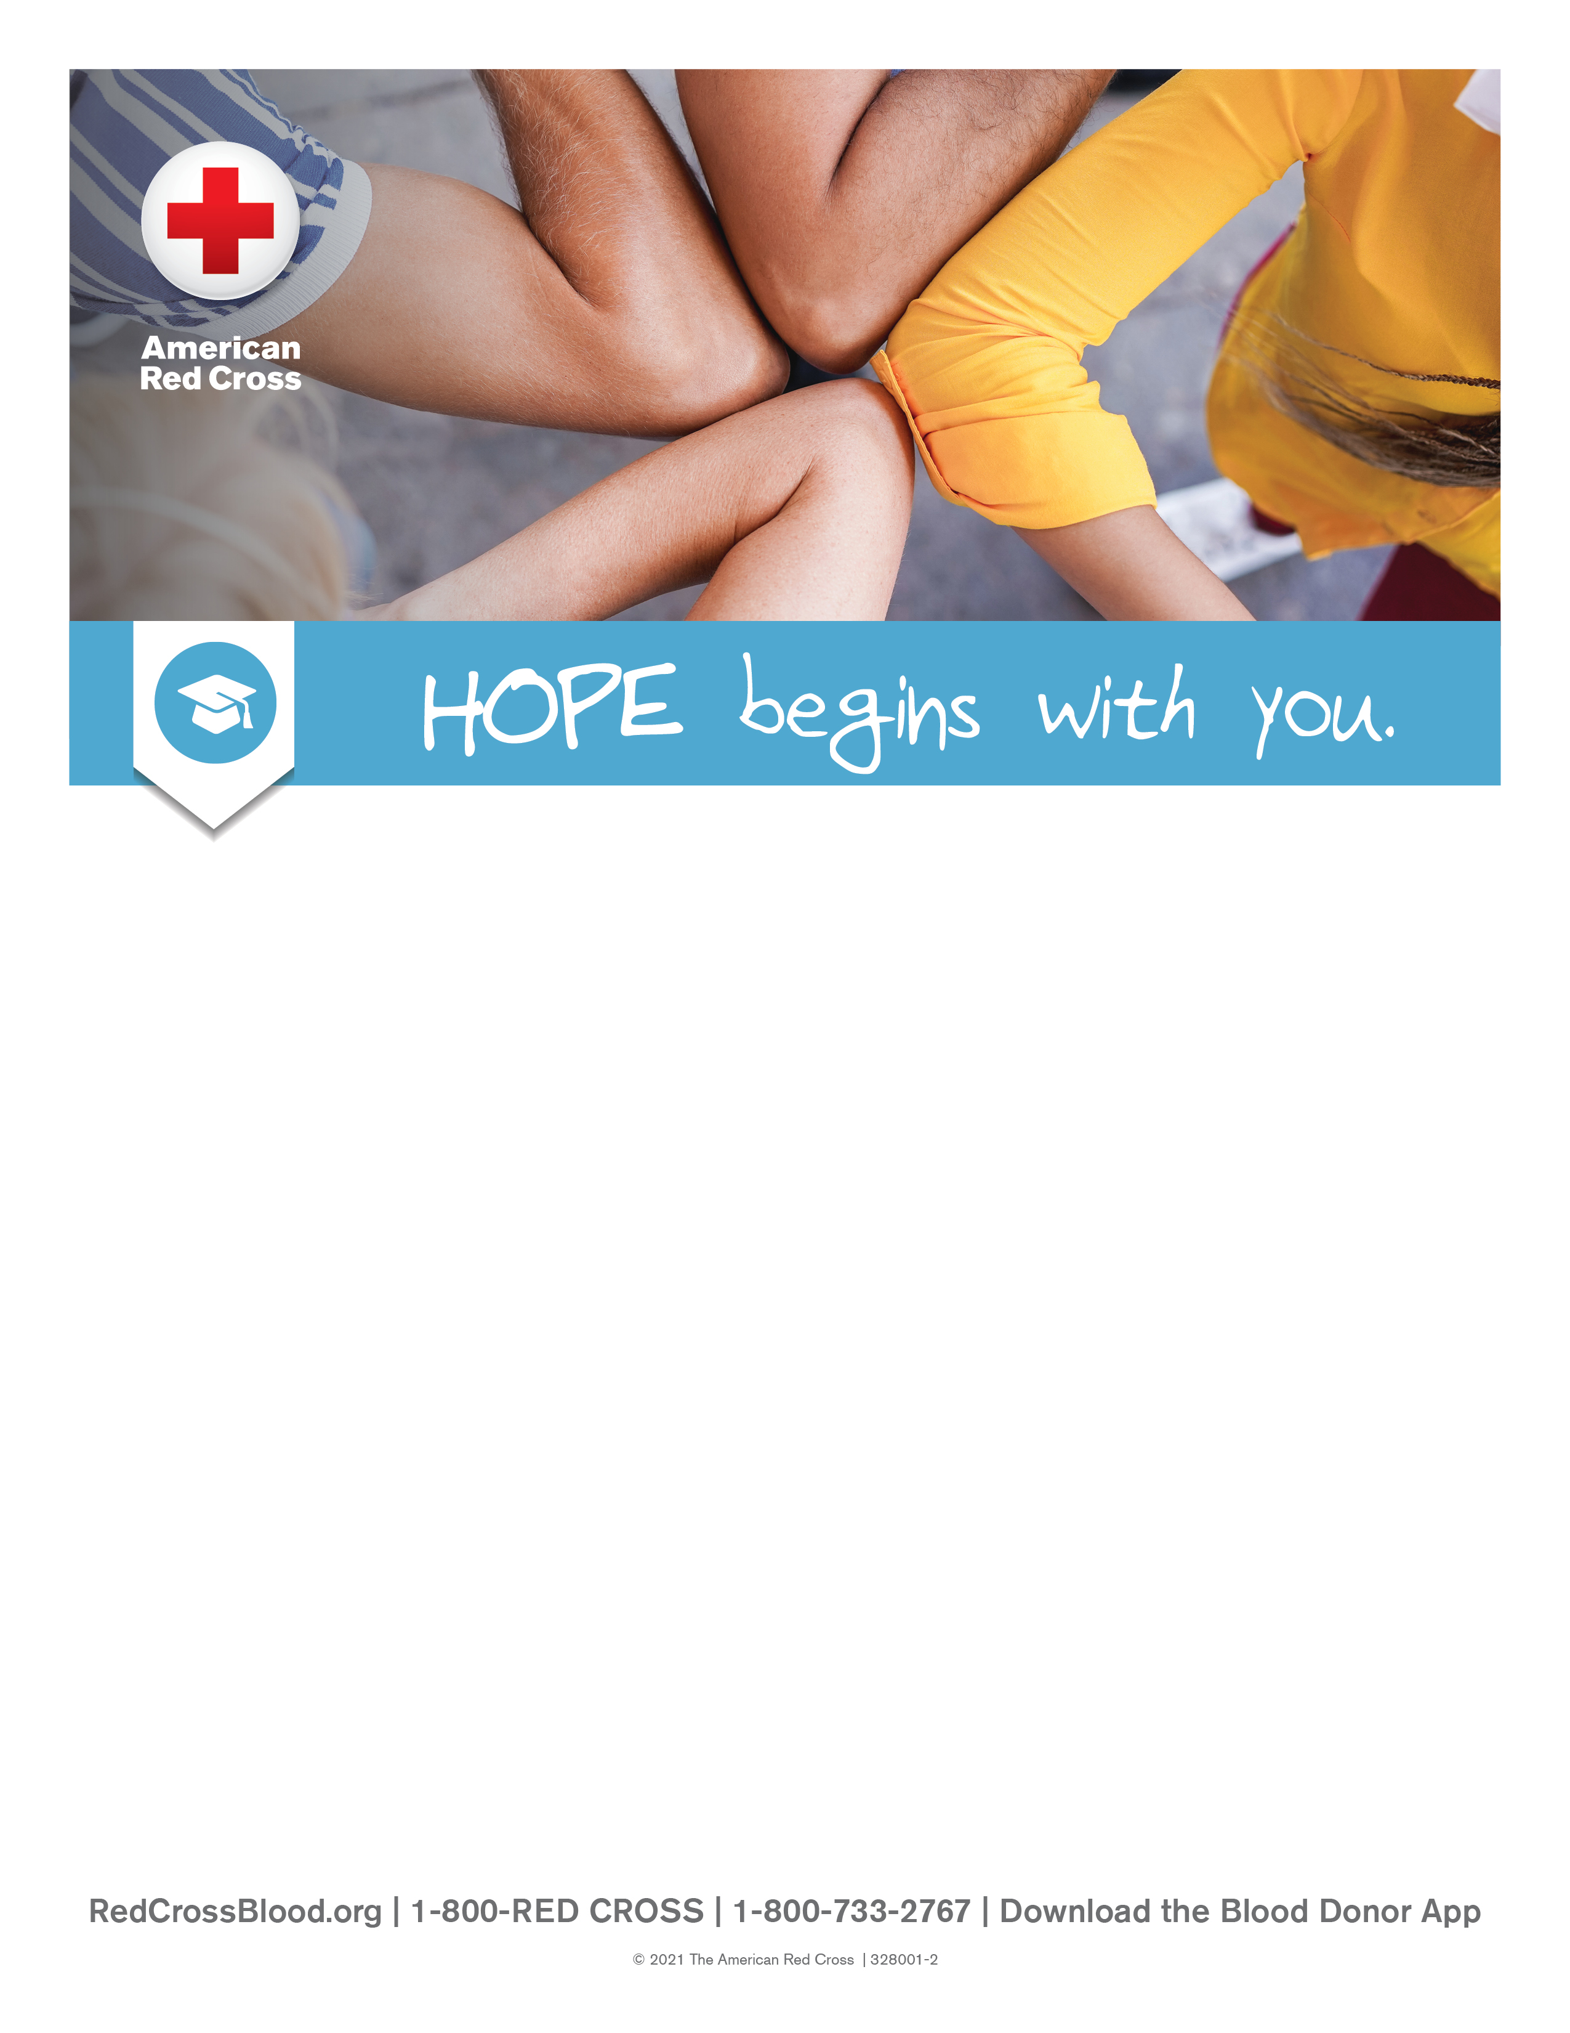

Columbus Preparatory Academy
3330 Chippewa St
February 4th, 2026
11:00am – 5:00pm
Contact information to sign up:
Josh Moorman
joshua.moorman@cpaohio.org
614-275-3600

